FOOD & TECH CLUB
PROJECT NEWSLETTER | FOOD ADULTERATION

“Know Your Food, Protect Your Health”
🌟 CLUB PROJECT HIGHLIGHTS
• Students investigated common food adulteration in everyday products.
• Simple scientific screening tests were used to identify possible adulterants.
• Students recorded observations, compared results and discussed the science behind each test.
• The project connected classroom Science with real-life consumer awareness.
• An awareness campaign was created through posters, slogans and student presentations.
• Students learned that household tests are screening demonstrations; confirmation requires laboratory testing.
🎯 PROJECT GOALS  • Understand the meaning and causes of food adulteration.  • Identify commonly adulterated food items.  • Develop scientific observation and investigation skills.  • Create awareness about food safety among students and families.  • Encourage responsible and informed consumer choices. | 🎤 STUDENT VOICES  • “We realised that food safety is not only a science topic—it is something we need to think about every day.”  • “The activity taught us to question what we buy instead of believing every label or advertisement.”  • “Doing the tests ourselves made the concept of adulteration much easier to understand.”
🔬 PROCESS / STEPS
IDENTIFY → RESEARCH → COLLECT SAMPLES → TEST → OBSERVE → RECORD → ANALYSE → CREATE AWARENESS
• Select common food samples and research possible adulterants.
• Conduct safe, teacher-supervised screening activities.
• Record observations in an observation sheet.
• Discuss the scientific principle behind each test.
• Prepare charts/posters and present findings to other students.
🧠 SKILLS LEARNED
• Scientific observation • Experimentation & investigation • Data collection & recording • Critical thinking
• Problem-solving • Teamwork & collaboration • Communication & presentation • Consumer awareness
• Creativity & poster designing • Responsible decision-making
⚠️ CHALLENGES & SOLUTIONS
Challenge | Solution
Students were unfamiliar with adulterants | Research-based introductory activity
Difficulty interpreting observations | Teacher demonstration and guided observation
Risk of confusing screening tests with proof | Explained the difference between screening and laboratory confirmation
Limited laboratory equipment | Used simple, safe classroom demonstrations
Difficulty presenting findings | Teams prepared charts and presentations
Lack of awareness among peers | Conducted an awareness campaign and quiz
🎯 MOTTO: “TEST BEFORE YOU TRUST – SAFE FOOD, HEALTHY LIFE!”
🏆 FINAL OUTCOME
Students moved from simply learning about food adulteration in textbooks to becoming young scientific investigators and responsible consumers.
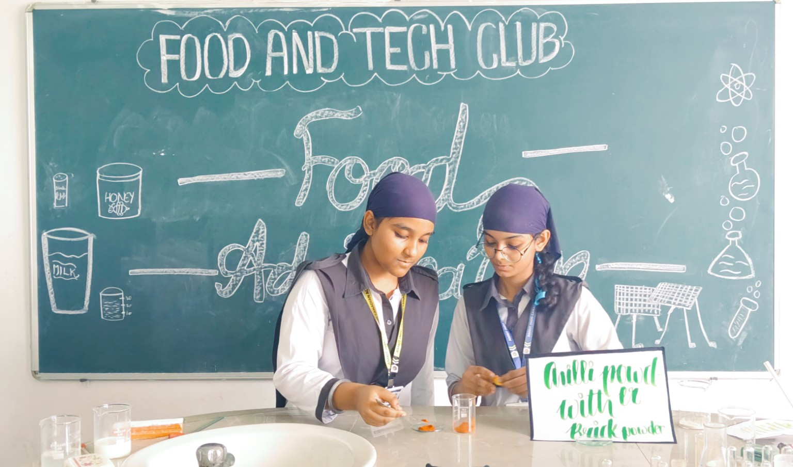 | 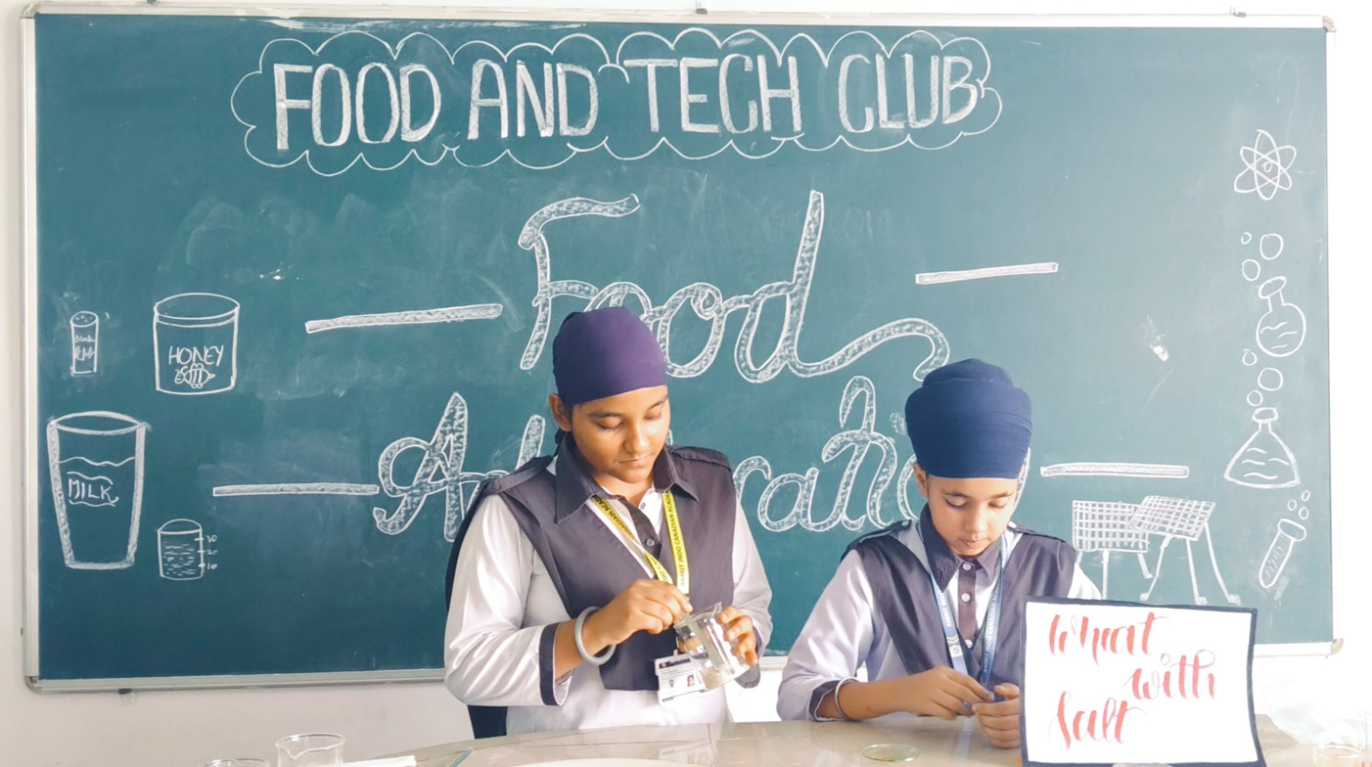 | 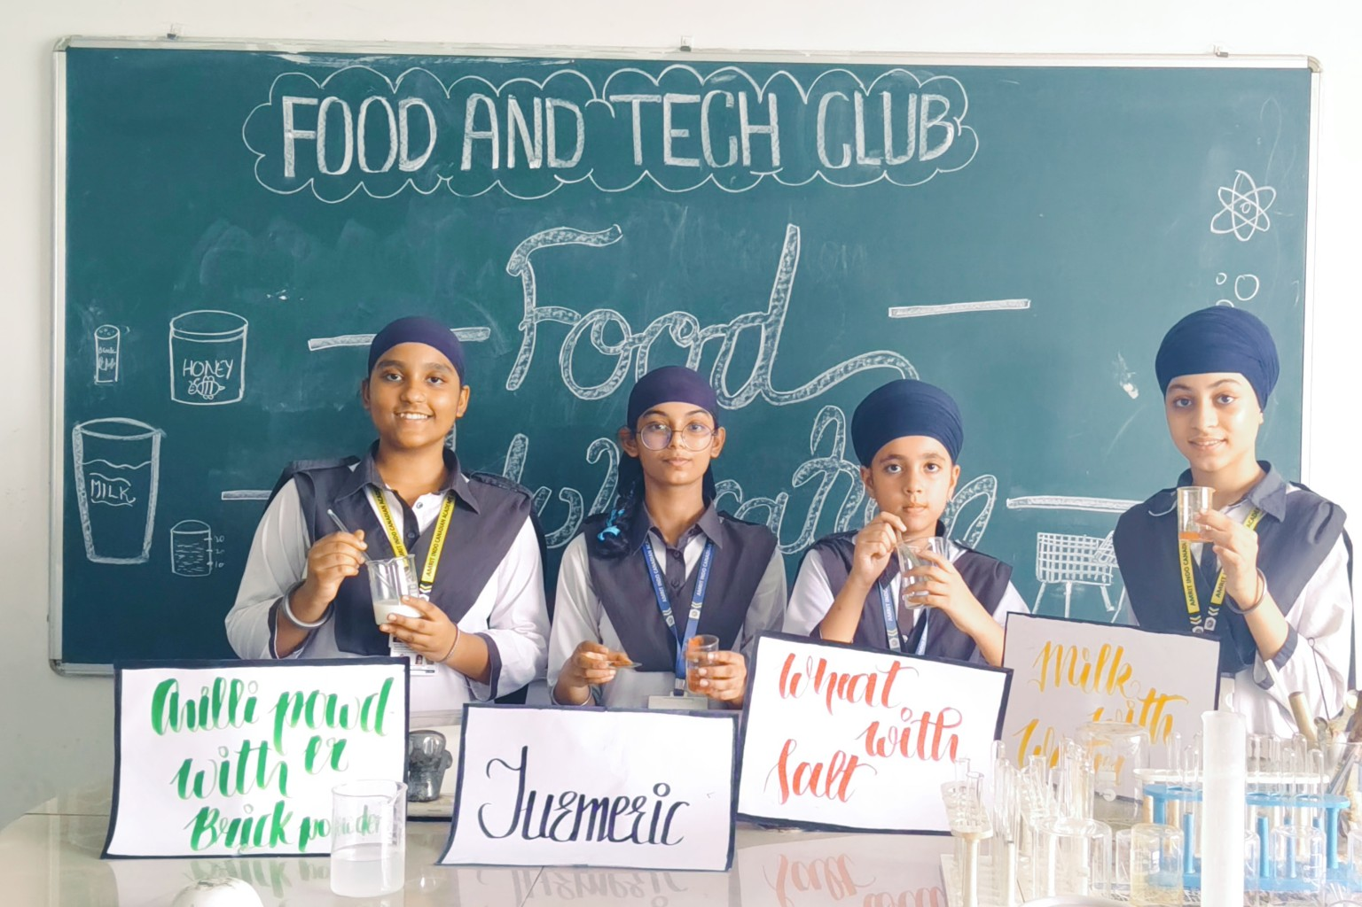 | 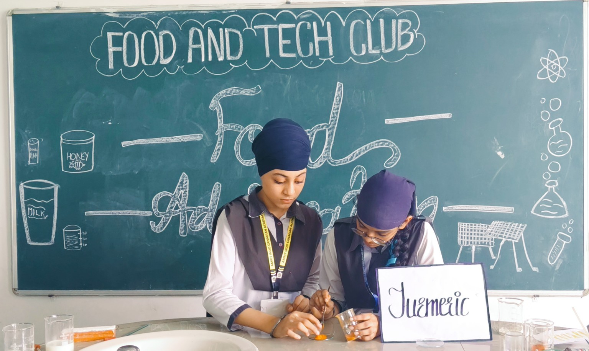
FOOD & TECH CLUB • LEARN • TEST • THINK • CREATE • CREATE AWARENESS

